AAT48160. DH AL/AL TRIFIRM RIVET 4.8*16.0 mm.
Batch no. 20230318. Order-No.:123456. Quantity: 532.000pcs.

Test no. 1, measurements test.
The dimension of ‘d’ should be 4.95mm max.
Test no.2, grip range test with lower grip range1.0mm.
The rest mandrel is deeply inside after setting test with hole size 5.0mm, all of 5 samples are found.
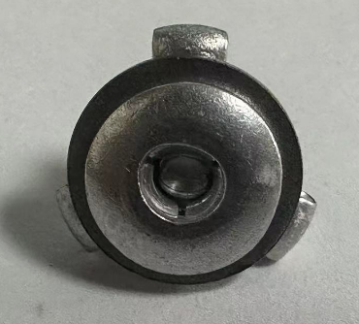

The rest mandrel is deeply inside after setting test with hole size 5.2mm, all of 5 samples are found.
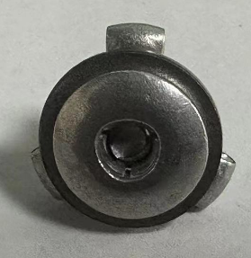

Test no.3, grip range test with upper grip range 4.0mm.
The rest mandrel is deeply inside after setting test with hole size 5.0mm, all of 5 samples are found.
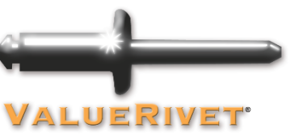
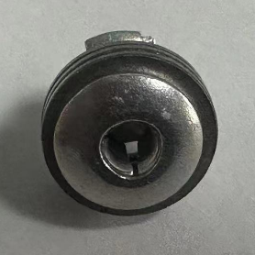

The rest mandrel is deeply inside after setting test with hole size 5.2mm, all of 5 samples are found.
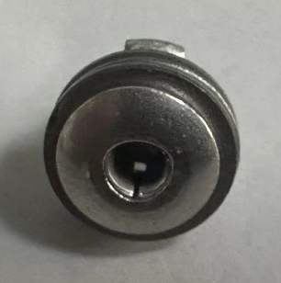

Test no. 4, mandrel retaining test.

Test no. 5, shearing test.
Required value:750N

Test no. 6, tensile test.
Required value:950N

Test no. 7, mandrel breaking test.

Test report samples | 
Supplier | Rivmate
Description | Tri-firm
Code | AAT488160
Batch (Lot no) | 20230318
Checked by
Date | 23.07.21

Test No 1  Measurements |  | Used calliper no.
Test No 1  Measurements |  | Mitutoyo WS-SXKC-086
 | Reference | Result | Picture
d | Max. 4.95 mm | 4.79 4.78 4.75 4.76 4.76
dk | Max. 10.10 mm | 9.81 9.87 9.81 9.96 9.88
k | Max. 2.10 mm | 1.83 1.87 1.82 1.85 1.86
dm | Max. 2.90 mm | 2.86 2.86 2.87 2.90 2.90
P | Min. 27.00 mm | 27.81 27.93 27.96 27.81 27.90
L | Nom. 15.7-16.8 mm | 16.19 16.21 16.14 16.34 16.31

Test No 2  Grip range test | Steel washer, thickness of  material 1.00mm/hole size of  test washers 5.00mm | Steel washer, thickness of  material 1.00mm/hole size of test  washers 5.20mm | Picture
Under grip range |  |  | Picture
Item 1 | Ok | Ok | 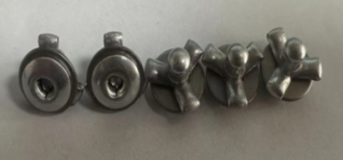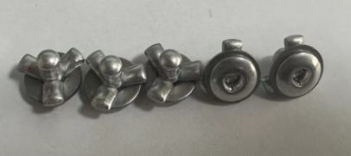
Item 2 | Ok | Ok
Item 3 | Ok | Ok
Item 4 | Ok | Ok
Item 5 | Ok | Ok
Test result (notes)

Test No 3  Grip range test | Steel washer, thickness of  material 4.00mm/hole size of  test washers 5.00mm | Steel washer, thickness of  material 4.00mm/hole size of test  washers 5.20mm | Picture
Upper grip range |  |  | Picture
Item 1 | Ok | Ok | 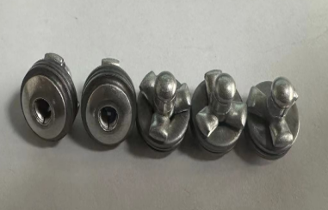  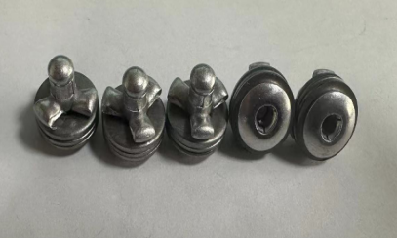
Item 2 | Ok | Ok
Item 3 | Ok | Ok
Item 4 | Ok | Ok
Item 5 | Ok | Ok
Test result (notes)

Test No 4  Retaining mandrel | Steel washer, thickness of  material 1.00mm/hole size of  test washers 5.00mm | Steel washer, thickness of  material 1.00mm/hole size of test  washers 5.20mm | Picture
Grip range |  |  | Picture
Item 1 | 794 | 758 | 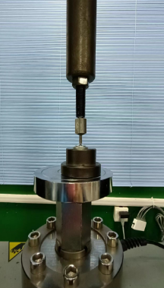
Item 2 | 725 | 726
Item 3 | 775 | 798
 | Steel washer, thickness of  material 4.00mm/hole size of  test washers 5.00mm | Steel washer, thickness of  material 4.00mm/hole size of test  washers 5.20mm
Item 1 | 772 | 749
Item 2 | 915 | 765
Item 3 | 768 | 791
Test result (notes)

Test No 5  Shearing strength  ISO 14589 |  |  | Picture
Grip range | Tool thickness of material  3.00mm / hole size of test tool  5.20mm | Ref data sheet | 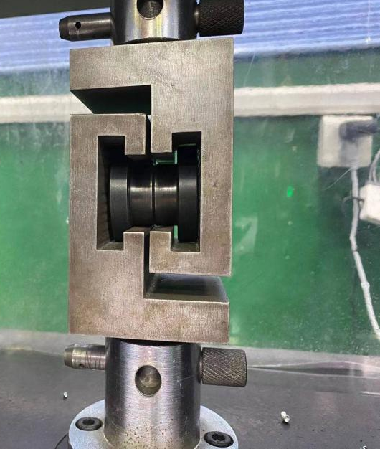
Item 1 | 1053 | Min 750 N
Item 2 | 1068 | Min 750 N
Item 3 | 1055 | Min 750 N
Item 4 | 1024 | Min 750 N
Item 5 | 1094 | Min 750 N
Test result (notes)
Details of testing  Machine for Test No. 5 | Diameter
Test tool no. | 5.20 x 1.50 mm
Test tool no. | 5.20 x 1.50 mm

Test No 6  Tensile strength  ISO 14589 |  |  | Picture
Grip range | Tool thickness of material  3.0mm / hole size of test tool  5.2mm | Ref data sheet | 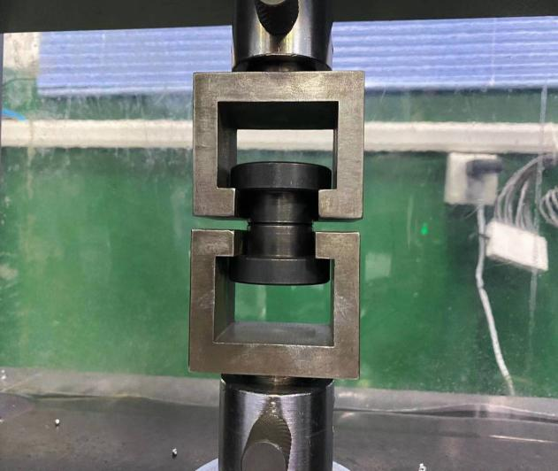
Item 1 | 1474 | Min. 950 N
Item 2 | 1492 | Min. 950 N
Item 3 | 1468 | Min. 950 N
Item 4 | 1415 | Min. 950 N
Item 5 | 1345 | Min. 950 N
Test result (notes)
Details of testing  machine for Test No. 6 | Diameter
Test tool no. | 5.20 x 1.50 mm
Test tool no. | 5.20 x 1.50 mm

Test No 7  Mandrel breaking test  ISO 14589 |  | Picture
 | Result | 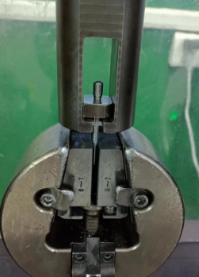
Item 1 | 1790N
Item2 | 1840N
Item 3 | 1810N
Test result (notes)

